

Data Technician

Name:
Course Date:
Table of contents
Day 1: Task 1 2
Day 1: Task 2 2
Day 2: Task 1 3
Day 2: Task 2 3
Day 3: Task 1 4
Day 3: Task 2 5
Day 4: Task 1 6
Day 4: Task 2 7
Course Notes 7
Additional Information 8

Day 1: Task 1

Please research the different versions of Tableau, compare and contrast them below and explain the limited functionality on ‘Tableau Public’.

Different Tableau versions | - Tableau Server: This is a paid business intelligence application designed for Windows or Linux servers that is commonly used by businesses. Interested enterprises can edit, organize and share Tableau dashboards. One of the main benefits of using this version is that it provides businesses with the service of storing vast amounts of user data and quickly accessing them from the cloud.  - Tableau Online: A paid analytics platform that is hosted in the cloud. Tableau Online users can publish dashboards and share them with anyone they choose. In addition, as with most online platforms of this calibre, there are live connections or extensions that can be imported into dashboards, such as Google BigQuery, Amazon Redshift etc. This version, therefore, can be good option for enterprises that value launching quickly and at scale without having to manage infrastructure.  - Tableau Public Server: A free server onto which visualizations and ideas can be posted - akin, to a mind map. Those who use this version have access to the world's largest store of data visualizations and can create their own online work portfolios. Data collaboration is streamlined when using this version, as it provides cloud-supported services and real-time analytics. Additionally, dashboards can be shared across mobile platforms.  - Tableau eLearning: Like Tableau Public, although it provides professional courses to upskill or enter a new career.  - Tableau Desktop: A paid desktop application that enables professionals to make dashboards, charts and formulas. This version allows users to connect data to create stories, dashboards and workbooks, then publish and share them to their own individual Tableau profile with the option of sharing to Tableau Public.  - Tableau Public Desktop: A free desktop application that provides only a cloud-save option rather than a live database connection - commonly utilized by various media outlets, writers, journalists and those who blog.  - Tableau Reader: This version can open and interact with extracted sources of data and packaged workbooks that were made in Tableau Desktop. Tableau Reader is able to open dashboards and facilitate interaction with them but does not allow users to edit formulas or charts. Those working with Tableau Reader can read the various Tableau file types.  - Tableau Mobile: A mobile application for Android and iOS users who can connect to Tableau Online and Tableau Server. Tableau Mobile allows users to interact with a dashboard's content and data. This app provides access to one's mobile site when they are away from their desktop device.  - Tableau Prep: One of Tableau's newest products. It is commonly used to clean; blend transform raw data. Additionally, it can be used for automated the redundant manual data cleaning and transformation (Ginsberg, C., 2025).
Ginsberg, C. (2025) What are the Different Tableau Products? [blog post]. Noble Desktop, 15 July. Available from: https://www.nobledesktop.com/blog/guide-to-tableau-products [Accessed: 7 December, 2025].

Day 1: Task 2

Using the EMSI_JobChange_UK dataset, create your own dashboard, I want to see a bar chart showing percentage change and a UK based map showing the key city locations impacted.

Paste your print screen here | 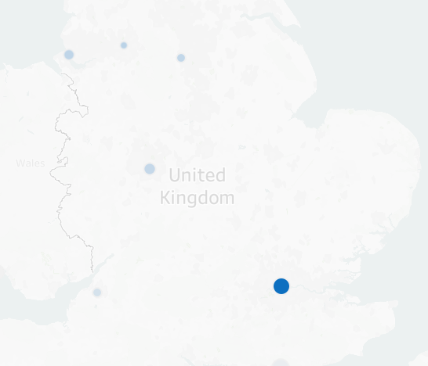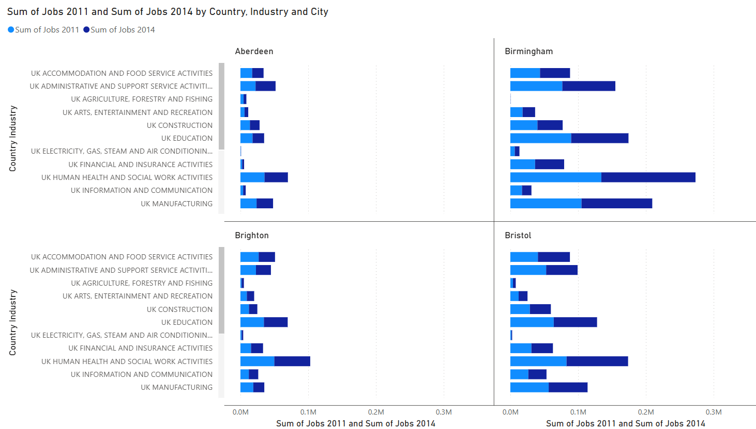

Day 2: Task 1

Using the Spotify data set, conduct an analysis to find trends and key information that could be used by an organisation for future projects.

There is no set scope for the analysis, simply to find trends and document them below:

Paste your print screens here | 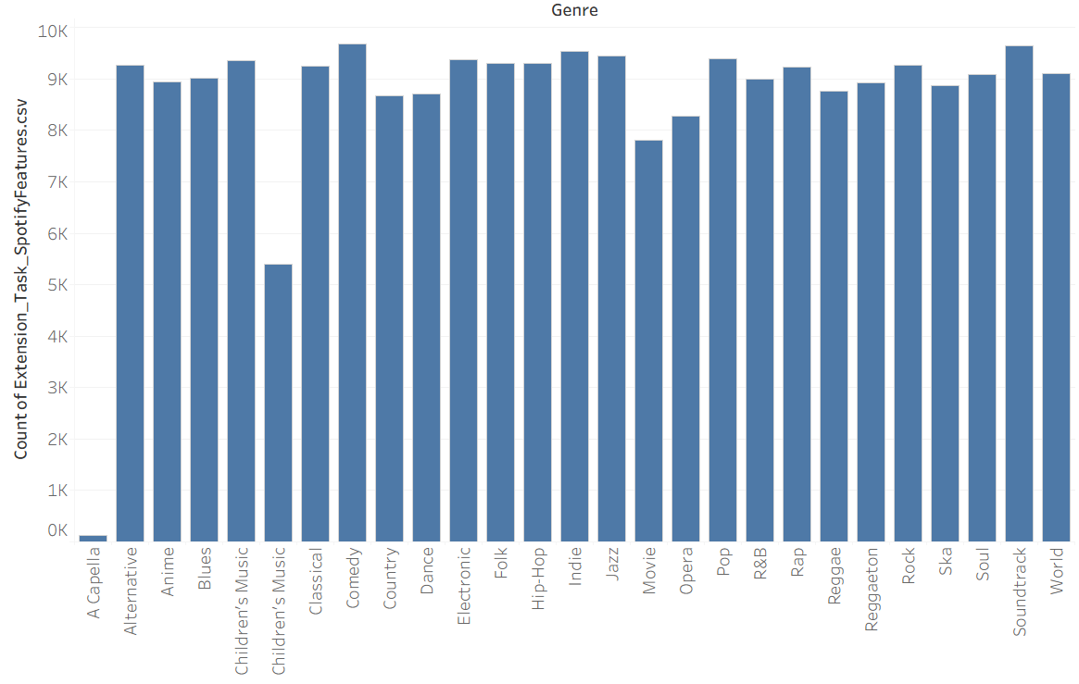

What did you find? | The data indicates that the dataset contains a variety of music genres, with a particularly strong representation of certain popular genres, and a few genres (like "A Capella") being less represented. The overall distribution seems balanced with a slight dominance of the more mainstream music types.

Day 2: Task 2

Using the Health, conduct an analysis to find trends and key information that could be used by an organisation for future support.

There is no set scope for the analysis, simply to find trends and document them below.

- Data can be lifesaving and is being used more within the NHS, reflect on how this data could support decision making for the NHS.

Paste your print screens here | 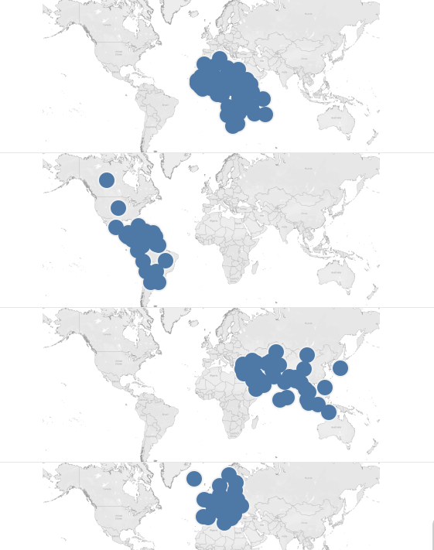
What did you find and any reflections on how the NHS could use this? | The NHS can use the global cancer case data to focus resources and efforts in regions with higher cancer prevalence by identifying high-risk areas and targeting cancer prevention, treatment, and screening programs. This data allows for more effective resource allocation, such as deploying specialists or establishing treatment centres in high-incidence regions. It can also guide awareness campaigns tailored to specific populations and inform global health partnerships. Tracking trends over time enables the NHS to anticipate future cancer cases, while regionalized screening programs can be optimized based on cancer types prevalent in specific areas. Ultimately, the data helps the NHS improve global health outcomes through targeted interventions and informed strategies.

Day 3: Task 1

Please complete Lab 1 ‘Get Data in Power Bi Desktop’. Once complete, paste a print screen below and in the collaboration board.

“Teaching is the best way to learn, so please listen out for support requests from the class and we’ll work through the challenges together”

Paste your completed lab here | 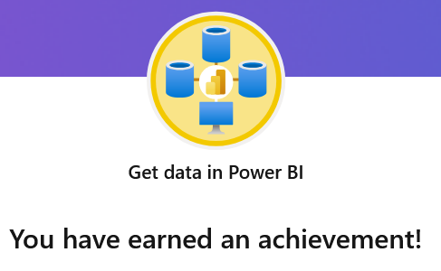

Day 3: Task 2

Please complete Lab 2 ‘Load Transformed Data in Power BI Desktop’. Once complete, paste a print screen below and in the collaboration board.

“Teaching is the best way to learn, so please listen out for support requests from the class and we’ll work through the challenges together”

Paste your completed lab here | 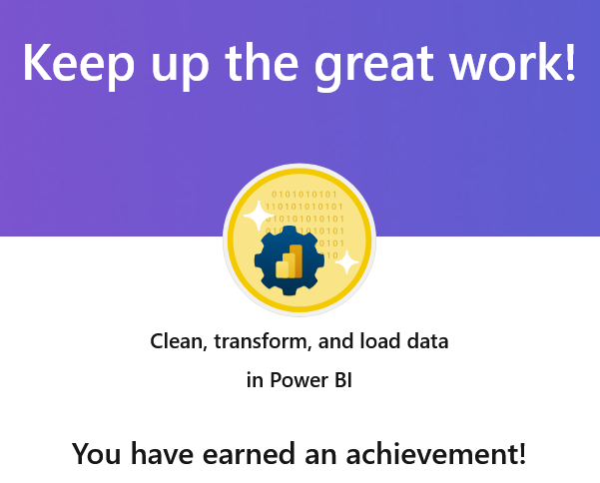

Day 4: Task 1

Please complete Lab 8 ‘Design a Report in Power BI Desktop’. Once complete, paste a print screen below and in the collaboration board.

“Teaching is the best way to learn, so please listen out for support requests from the class and we’ll work through the challenges together”

Paste your completed lab here | 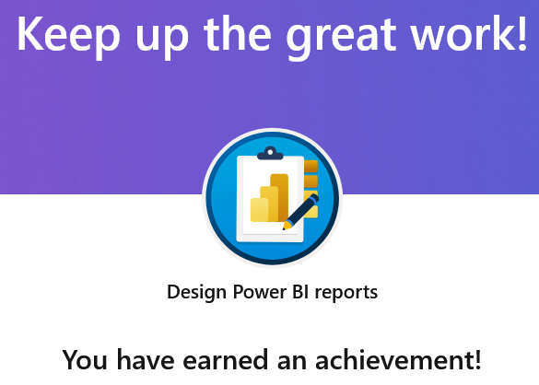

Day 4: Task 2

Please complete Lab 12 ‘Create a Power BI Dashboard’. Once complete, paste a print screen below and in the collaboration board.

“Teaching is the best way to learn, so please listen out for support requests from the class and we’ll work through the challenges together”

Paste your completed lab here | 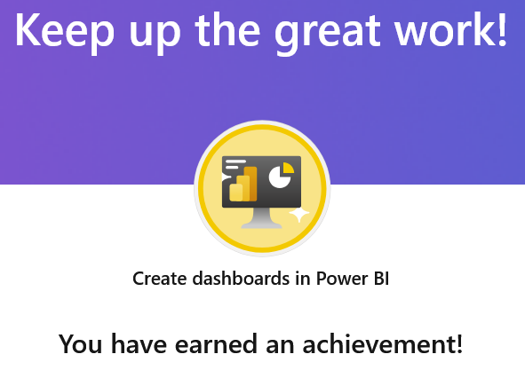

Course Notes

It is recommended to take notes from the course, use the space below to do so, or use the revision guide shared with the class.

We have included a range of additional links to further resources and information that you may find useful, these can be found within your revision guide.

END OF WORKBOOK

Please check through your work thoroughly before submitting and update the table of contents if required.

Please send your completed work booklet to your trainer.

Information

